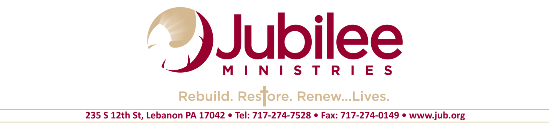
JOB OPPORTUNITY

Development Administrator Full Time
Lebanon, PA

Purpose: To assist the CEO and Development Director in areas of fundraising, publications, and events.
Qualifications:
- Strong interpersonal and communication skills, and the ability to work effectively with others.
- Team player focused on the overall success of the organization.
- Basic knowledge of planned giving concepts and strategies.
- Self-starter who is highly motivated with excellent organizational, planning and time- management skills, including demonstrated ability to manage multiple tasks effectively.
- Demonstrated competence with a variety of software programs including Microsoft Office and the organization’s donor-management software.
- Able to communicate well orally and in written form.
- Ability to plan and coordinate special events.
- Willing to adhere to Jubilee’s Statement of Beliefs and Core Values.

Working Conditions/Physical Factors: Will work in an office setting and in the community. Requires some travel in either personal or company vehicle. Minimum lifting not to exceed 40 pounds with some bending, stretching or twisting. This position will require evening and weekend work.

All applicants must be willing to adhere to
Jubilee's Statement of Beliefs and Core Values.

Please complete an application at our stores or online at: www.jub.org/employment
and forward it with your resume to HR@jub.org
If you have inquiries concerning employment,
you may also email HR@jub.org.

